ISSACK WAITHAKA
cs-sa07-24085

The first thing to do was to start the machine

1. Enumeration
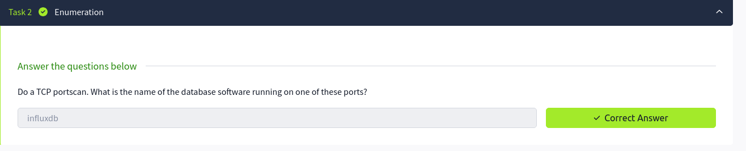
I conducted an nmap scan which gave the following results
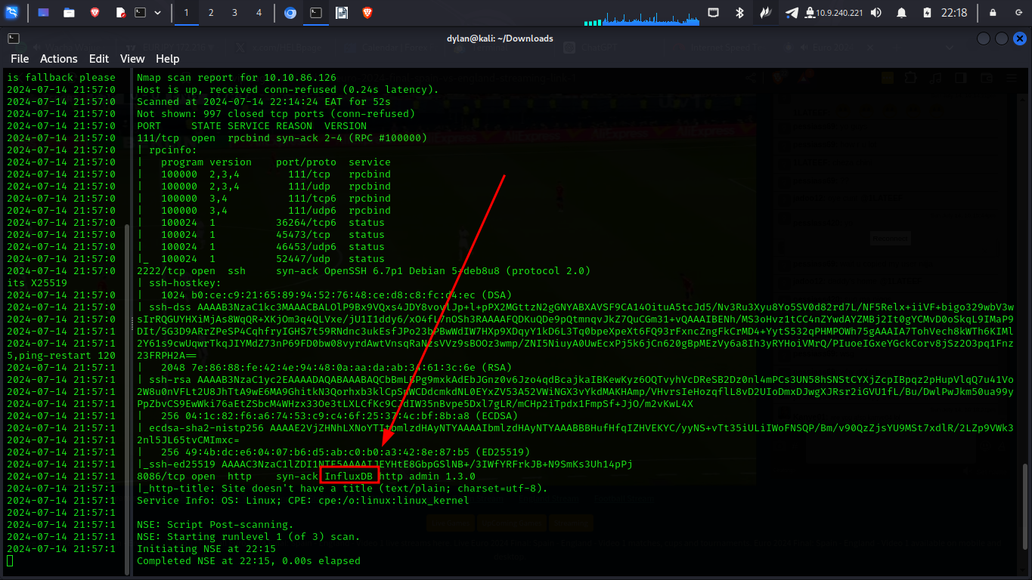
2.Data exploration and user flag
a)
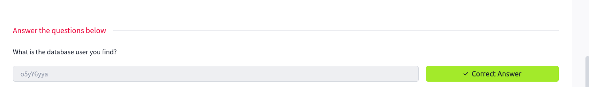
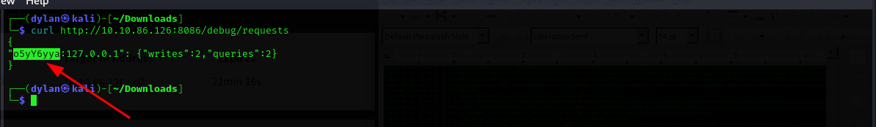

3.
I was able to login to the data base
To login I created a payload that would create a user and password that I would use as credentials to login
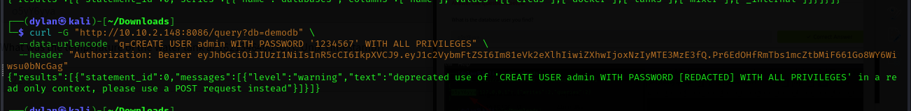
and with that I was able to login
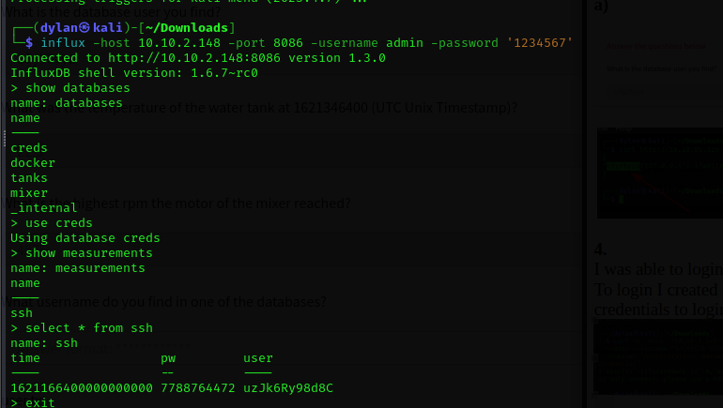
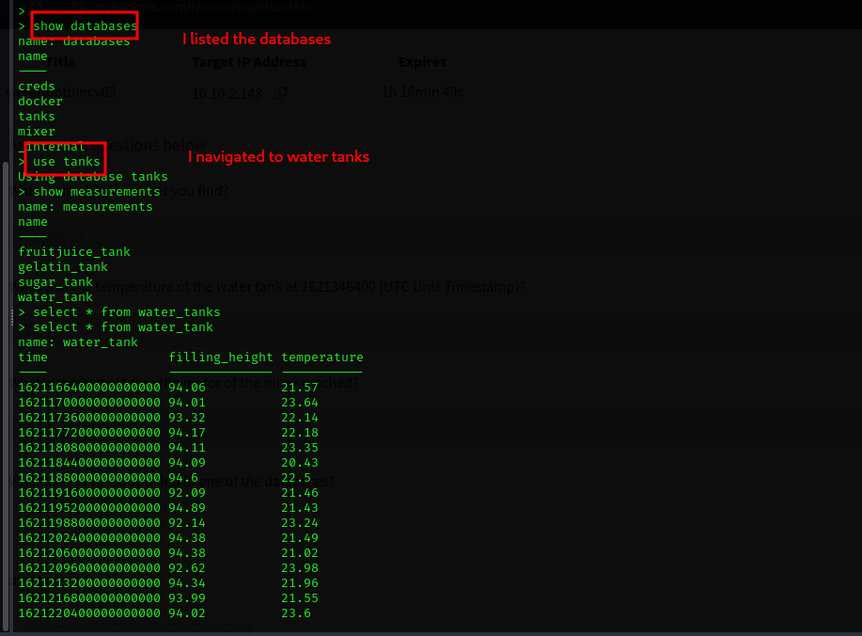

That is how I got the answer
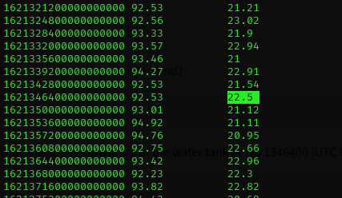

4.
To get the highest rpm I navigated to the mixer database
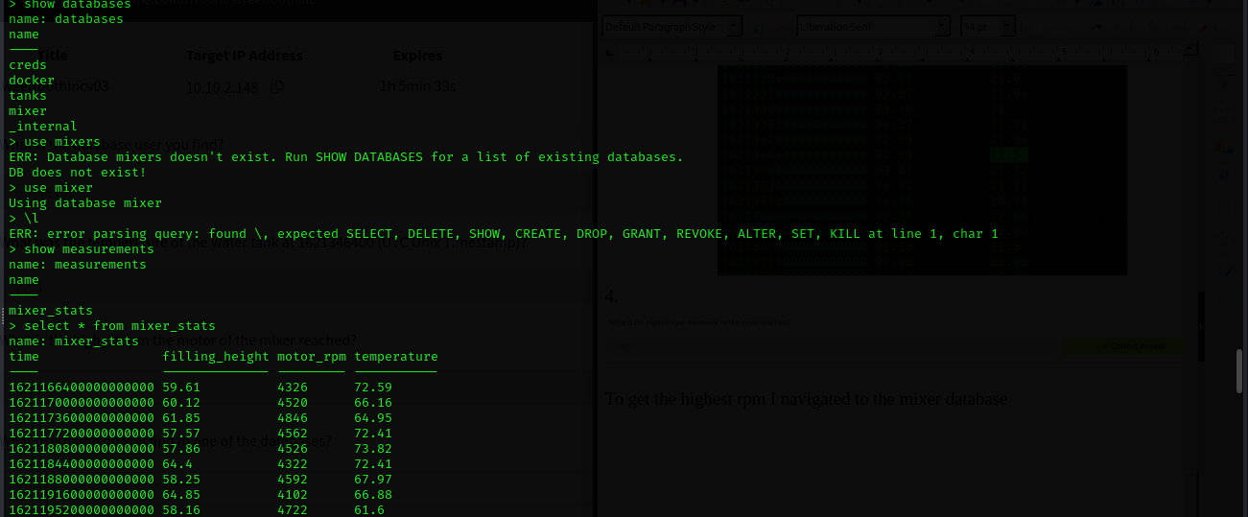
I went through one by one until I found it

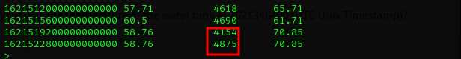

5.
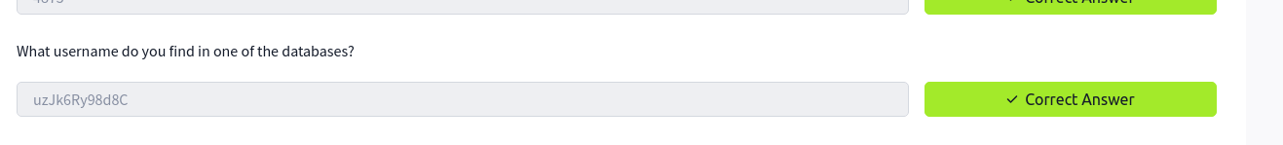
I navigated to the creds database and queried all the items available in the database
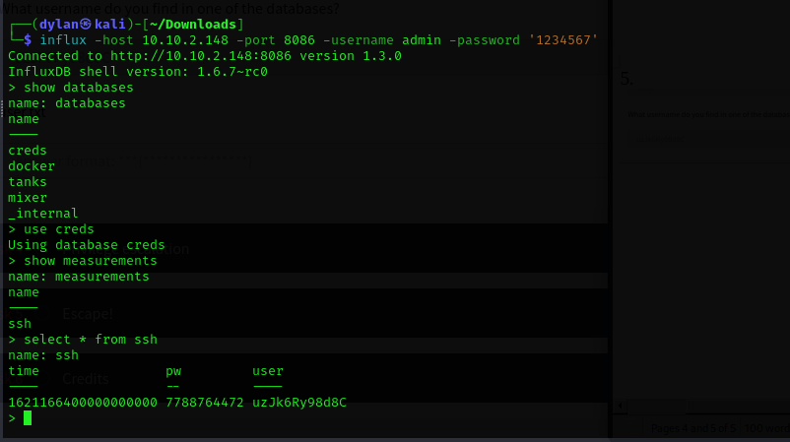
6.
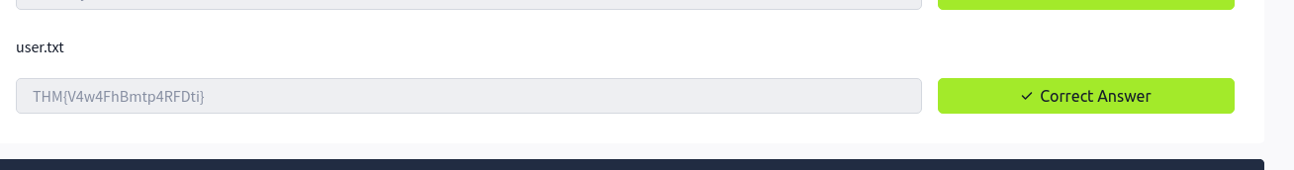
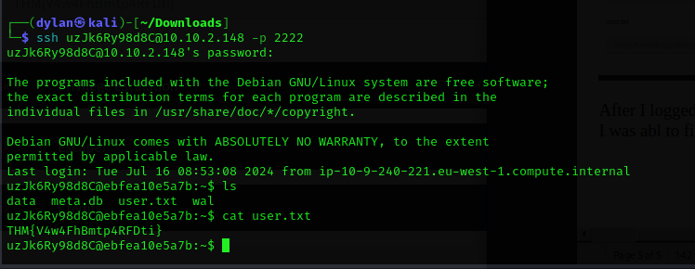
After I logged in using ssh as the user with the credentials I found at the creds database, I was able to find the user.txt file

7.
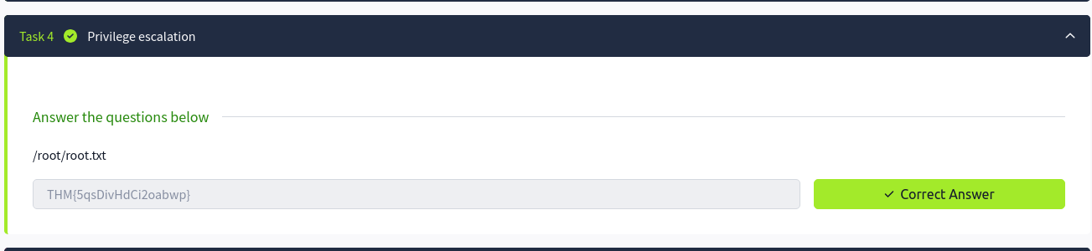
- To access this I needed to do a privilege escalation to the root directory. First I connected to docker so that I could I could list the items in the container
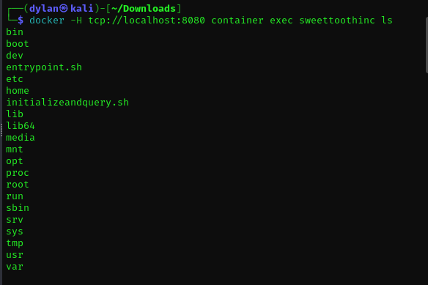
- I created a script which I was to download into the docker container.
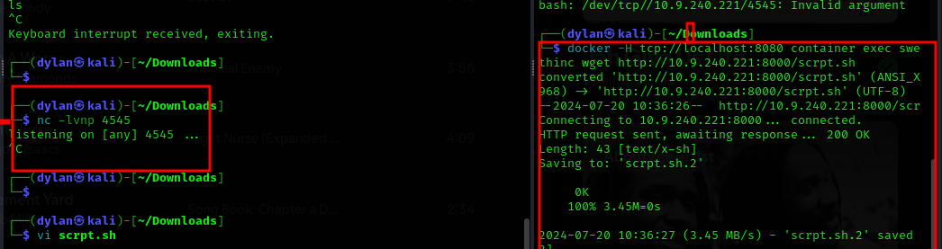
-

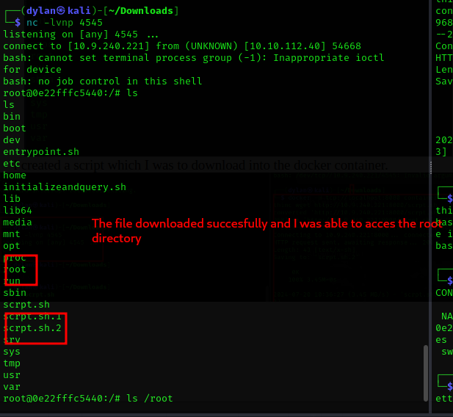
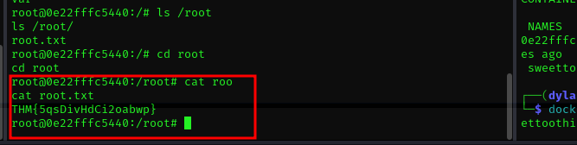

8.
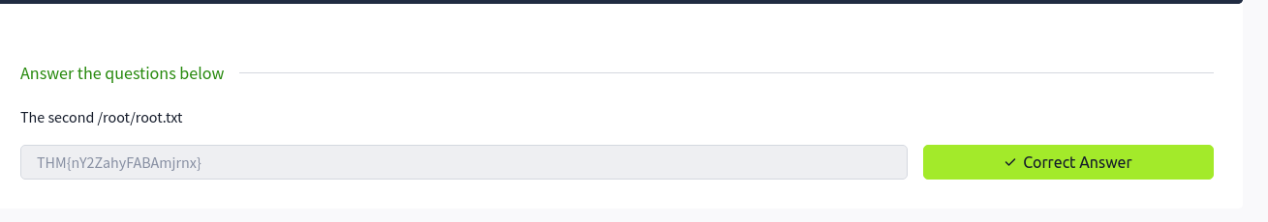
To get this I used the df which would display the disk space. This should not be visible in a docker container. So I tried to mount the hard drive within docker container
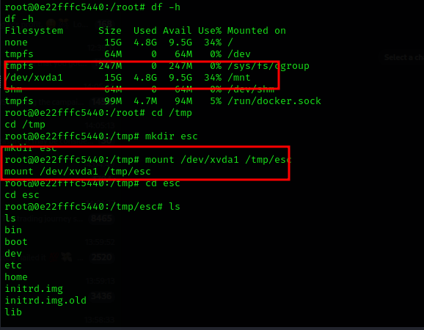

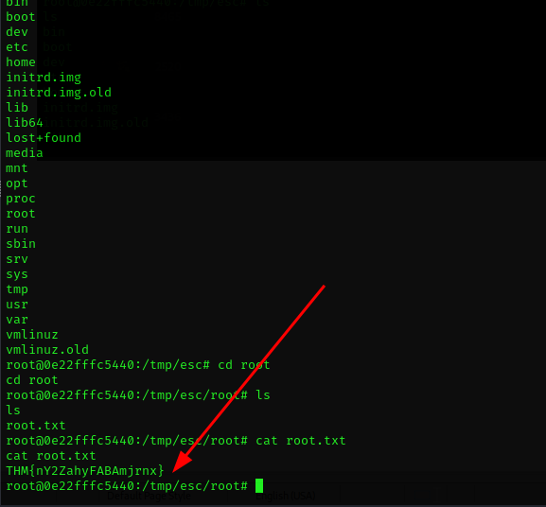
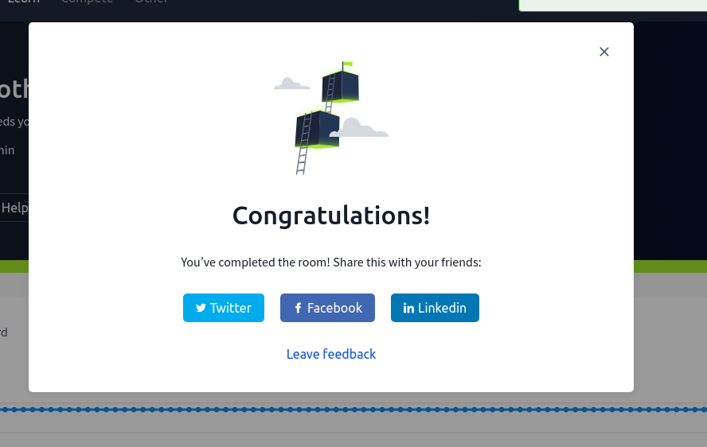

Conclusion
- I gained practical experience in using tools and techniques for reconnaissance, enumeration, and exploitation. I have learned that tools like docker comes in handy when it comes to cyber security. This room enhanced my understanding of common security flaws, such as authentication bypasses, and how to mitigate them. It was quite challenging though but I am glad I was able to finish it.

